# Apply filters to SQL queries

## Project description

In this lab, our adjectives are to demonstrate the following:

* The ability to retrieve after hour failed login attempts
* Retrieve login attempts on specific dates
* Retrieve login attempts outside of Mexico
* Retrieve employees in Marketing
* Retrieve employees in Finance or Sales
* Retrieve all employees not in the IT department

For this scenario, I needed to obtain specific information about employees, their machines, and the departments they belong to from the database.

## Retrieve after hours failed login attempts

To start this, we first want to see if there were any attempts after hours to access the server. Since 6 pm is considered after hoursFor this objective, we use the ‘AND’ filter to retrieve information that meets both requirements.

I needed information that has both the login attempts after 6:00 pm AND whether the success rate was a failure. Here was the string:

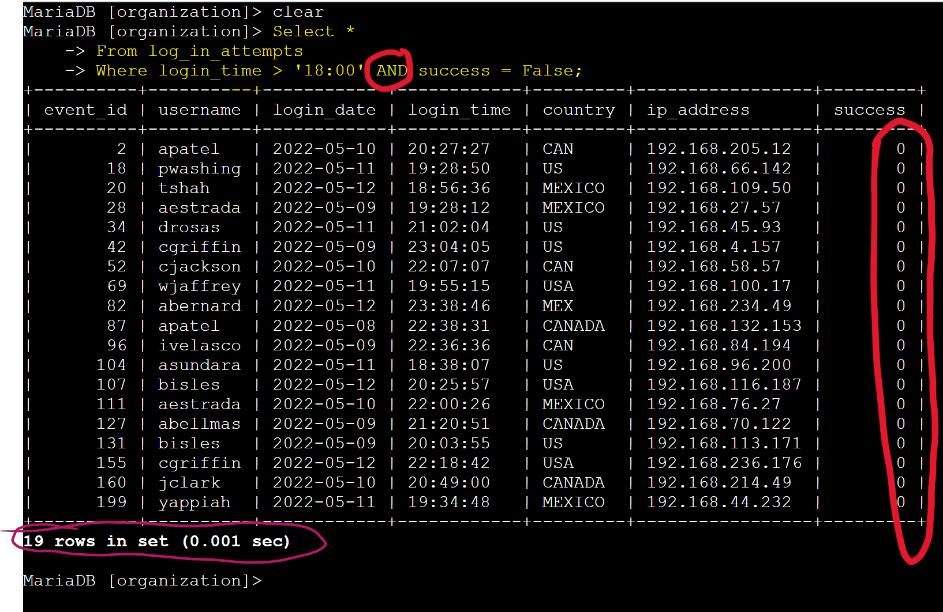

The word ‘False’ was used to describe the failed attempt in the string, which then is represented by ‘0’ the ‘success’ column. As you can see, all attempts made after 6:00 were unsuccessful.

Retrieve login attempts on specific dates

In this objective, I needed to retrieve all login attempts on ‘2022-05-08’ and ‘2022-05-09’. For me to retrieve the information for both dates, I had to use the ‘OR’ filter in the string. This will give me results having either dates.

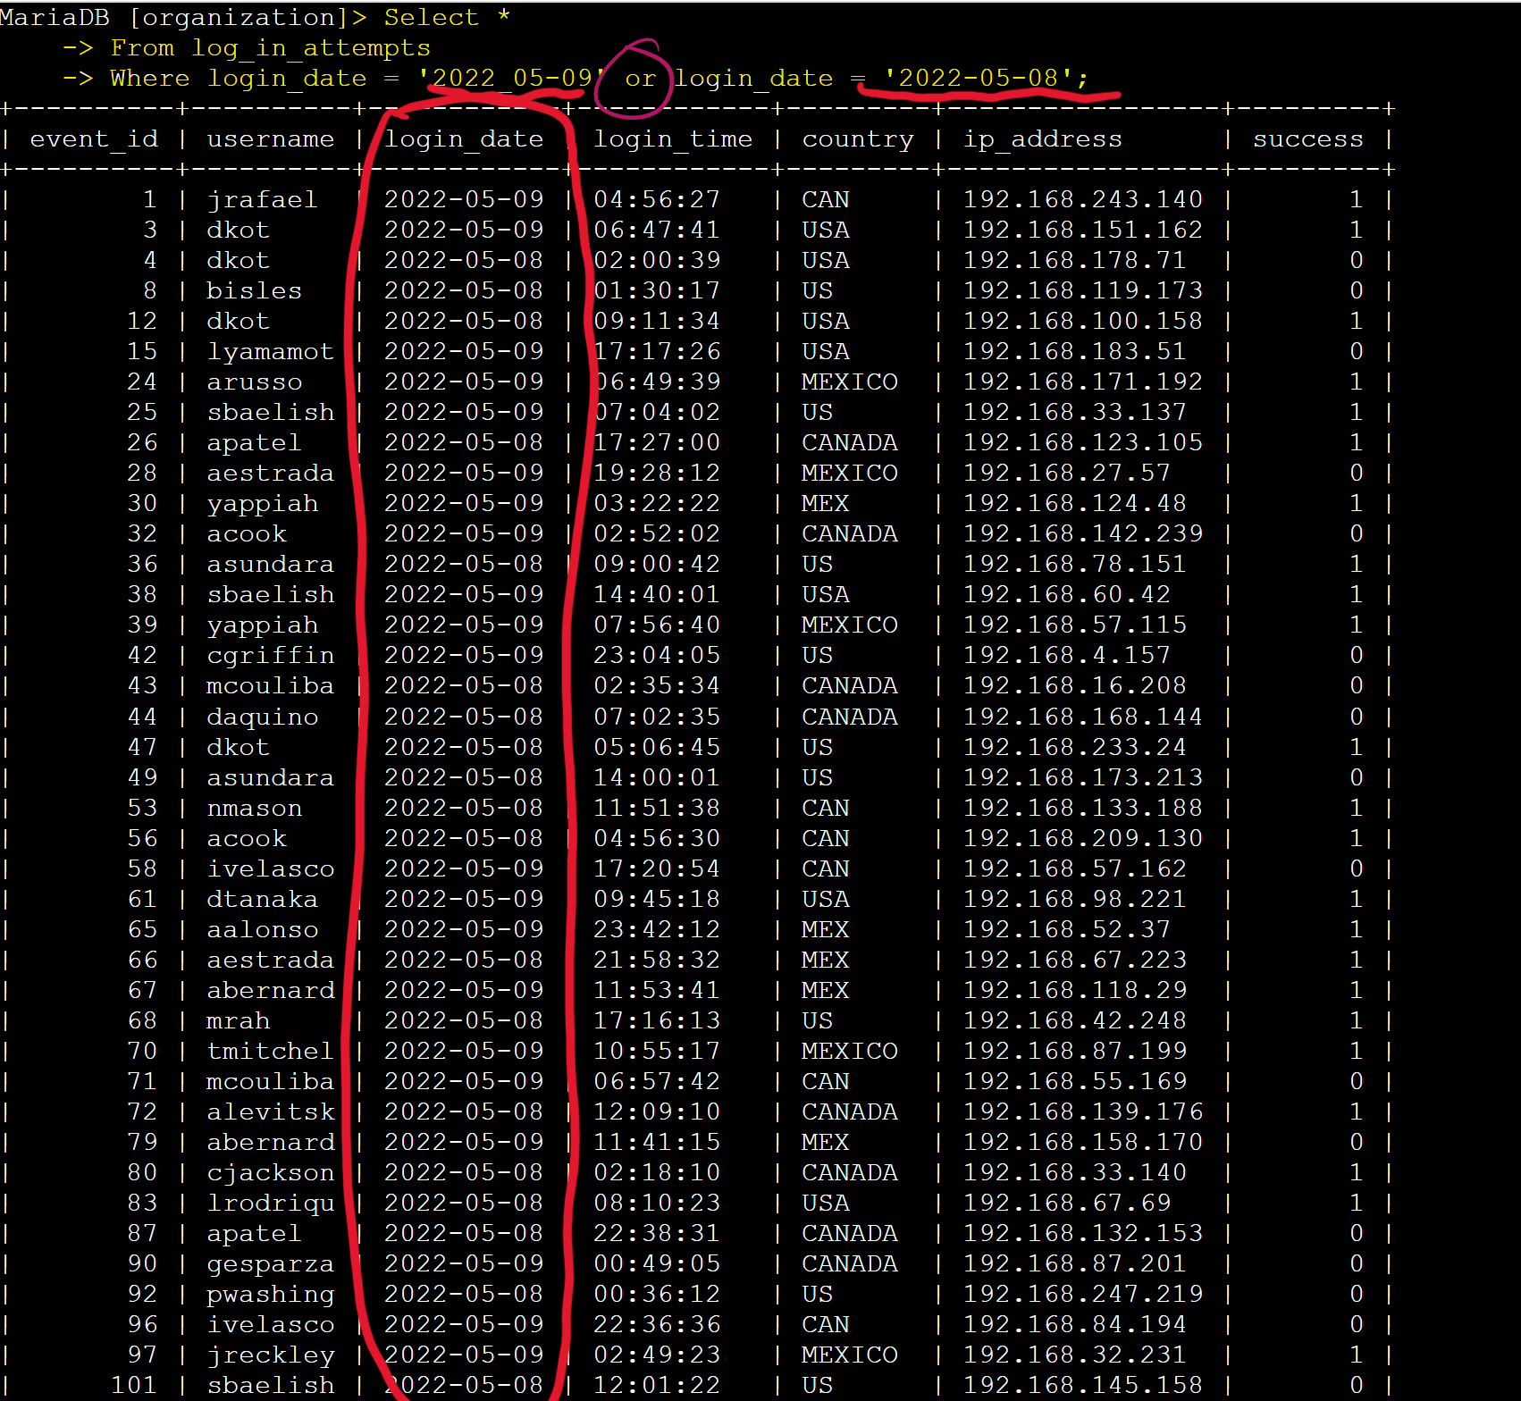

## Retrieve login attempts outside of Mexico

For this objective, I had to retrieve login attempts that occurred outside of Mexico. In order to retrieve the information, I had to use the ‘NOT’ filter that is placed after the ‘WHERE’ keyword. The ‘NOT’ filter will exclude any information with the selected word, phrase, or number. To include additional spellings of ‘Mexico’ with a ‘%’ wildcard added to include ‘MEX’ in the search results. The ‘LIKE’ filter was used after the ‘country’ keyword to include ‘MEX’

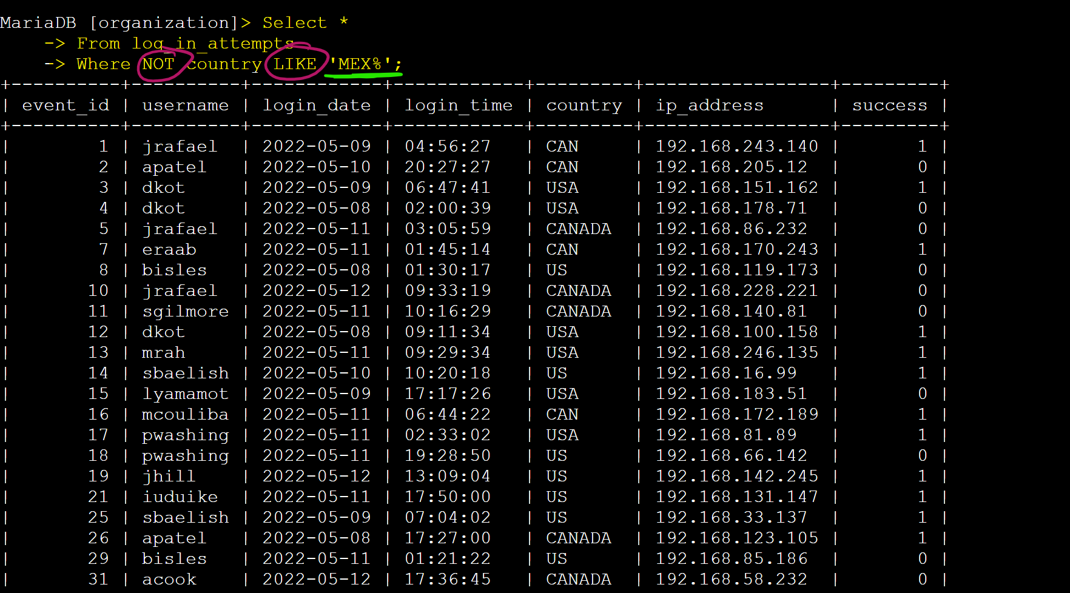

## Retrieve employees in Marketing

In this objective, I had to retrieve all the employees that were in the ‘Marketing’ department that worked in the ‘EAST’ wing. In order to do this, I had to use the ‘AND’ filter to include the ‘Marketing’ and ‘East’ keywords, and the ‘LIKE’ filter to find all room numbers in the ‘EAST’ wing. The ‘%’ wildcard was used again at the end of ‘EAST’ keyword to retrieve all room numbers in the ‘EAST’ wing. 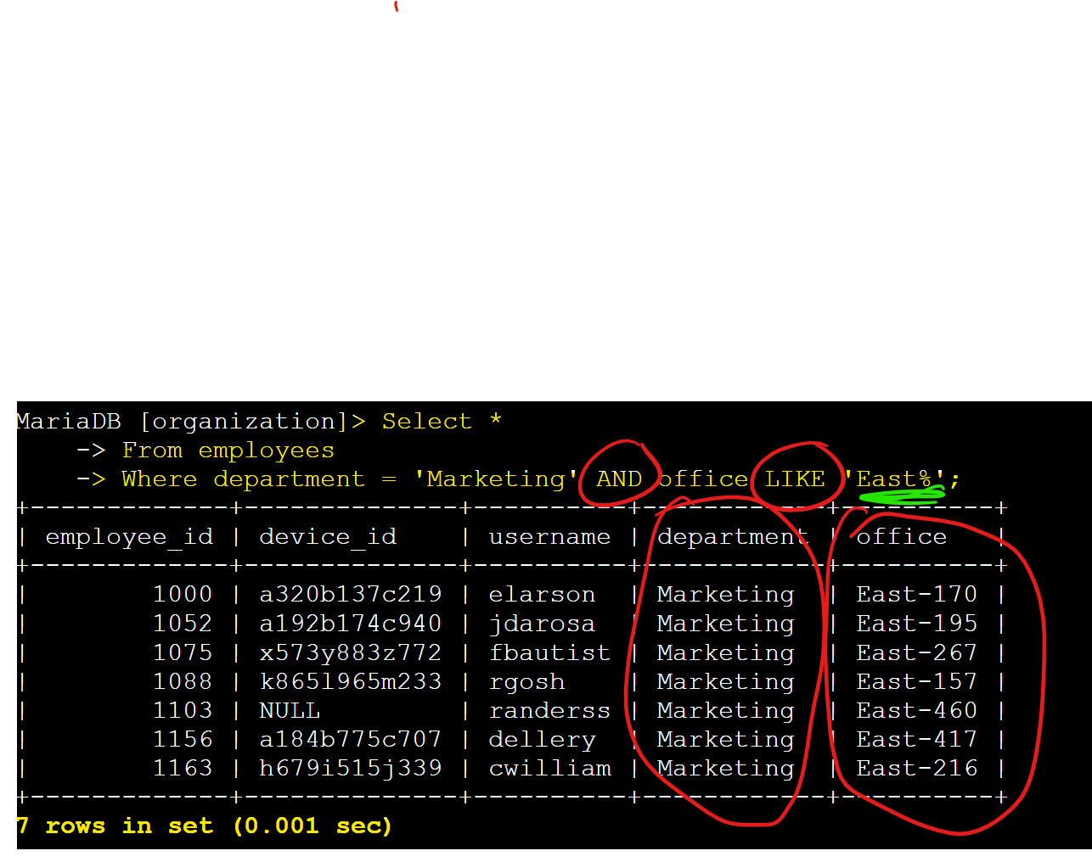

## Retrieve employees in Finance or Sales

In this objective, I had to retrieve all the employees that are only in the Finance and Sales departments. For this, I used the ‘OR’ filter in the WHERE keyword string. ‘department =’ must be typed out for each department you are searching for.

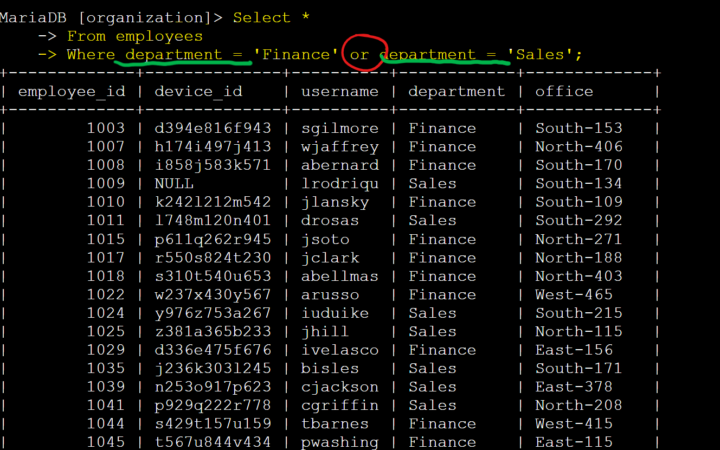

## Retrieve all employees not in IT

Finally, the last objective in this lab is to retrieve employees from all departments except for the one in the IT or Information technology department. In order for me to do it, I had to use the ‘NOT’ filter after the ‘WHERE’ keyword to retrieve this specific information.

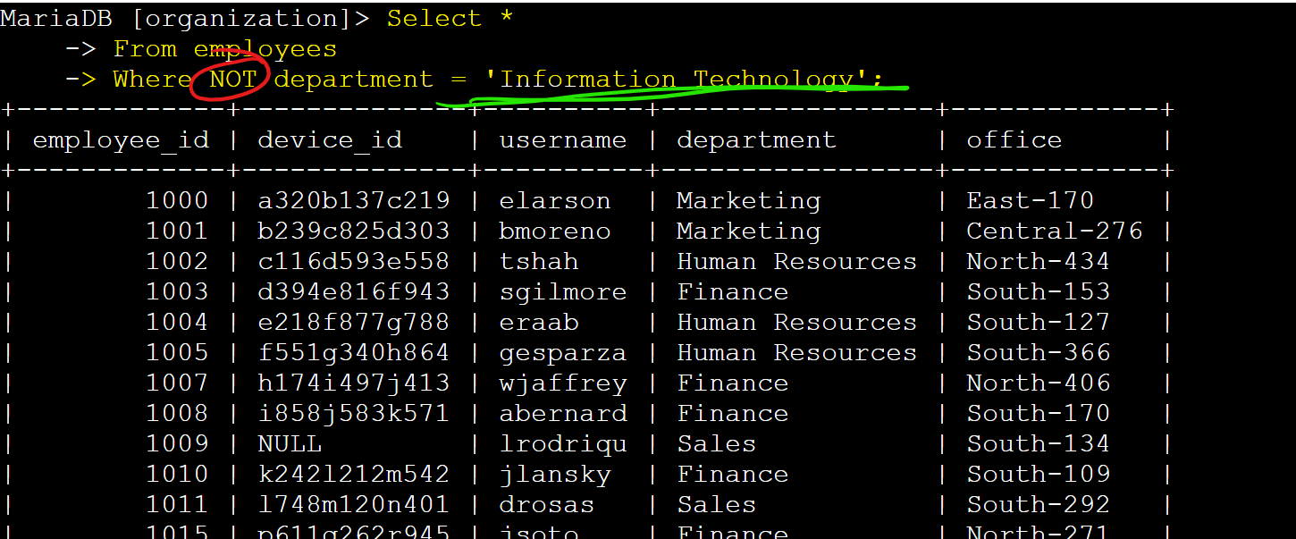

## 

## Summary

In this lab my objectives were:

* The ability to retrieve after hour failed login attempts
* Retrieve login attempts on specific dates
* Retrieve login attempts outside of Mexico
* Retrieve employees in Marketing
* Retrieve employees in Finance or Sales
* Retrieve all employees not in the IT department

I believe I have demonstrated that I can complete all the tasks asked of me in this, using the correct filters in the right scenarios.